**Saveetha School of Engineering, SIMATS Thandalam, Chennai**

**March – 2024**

Submitted by

**MAHESH BABU KOPPALA (192111329)**

Guided by

Dr.M.buvanesvari

**Saveetha School of Engineering, SIMATS Thandalam, Chennai**

**ABSTRACT**

The Income Tax Calculator Project is a sophisticated software solution designed to simplify the complex task of calculating individual income tax liabilities. With a user-friendly interface, individuals can easily input their financial details, such as income, deductions, and exemptions. The calculator performs real-time calculations, taking into account the latest tax laws and regulations to provide an accurate estimate of the user's tax liability. Regular updates ensure that the calculator reflects the most current tax policies. The project also incorporates graphical representations for users to visualize their tax breakdown, scenario analysis for financial planning, and robust security measures to protect sensitive data. Accessible online from various devices, the calculator generates comprehensive reports summarizing income, deductions, and tax liabilities, contributing to a more transparent and accessible tax assessment experience and promoting financial literacy.

This holistic set of features aims to empower users with insights, educational tools, and planning assistance, making the Income Tax Calculator Project a versatile and user-centric platform for navigating the complexities of income tax calculations and financial decision-making. With features such as personalized tax optimization suggestions, the ability to compare current tax liabilities with previous years or alternative scenarios, and integration with various financial data sources, the project offers a comprehensive approach to tax assessment. It goes beyond computation by providing educational resources for financial literacy, a retirement planning module, and assistance with tax filing.

**INTRODUCTION**

The Income Tax Calculator project is distinguished by its commitment to user empowerment and adaptability to the ever-changing landscape of tax regulations. The calculator's real-time calculations take into account the latest tax laws, ensuring users receive accurate and up-to-date assessments. Personalized tax optimization suggestions add a proactive dimension to the tool, guiding users towards potential deductions and credits that align with their unique financial situations. The scenario analysis feature allows users to explore different financial scenarios, fostering a deeper understanding of how various factors influence their tax liabilities.

In addressing the contemporary need for financial literacy, the Income Tax Calculator Project incorporates educational resources such as tooltips and explanations. This not only facilitates users' comprehension of their tax situations but also contributes to a broader goal of enhancing financial literacy. The project's commitment to data security ensures that users can trust the platform with their sensitive financial information. By making the tool accessible across various devices, the project recognizes the importance of flexibility in today's digital age.

Moreover, the integration with financial data sources allows users to seamlessly import relevant information, streamlining the data input process. As a versatile platform, the Income Tax Calculator is not only a valuable resource for immediate tax calculations but also serves as a central hub for users' broader financial planning needs. With its multifaceted approach, the project aims to redefine the user experience of income tax calculations, promoting transparency, accessibility, and informed financial decision-making.

**DESCRIPTION**

The Income Tax Calculator is a powerful and user-centric software tool designed to facilitate accurate and efficient computation of individual income tax liabilities. This application features an intuitive interface that allows users to input diverse financial information, including income from various sources, deductions, and exemptions. One of the standout features is its real-time calculation engine, which dynamically processes user-input data based on the latest tax laws, rates, and exemptions, providing users with an up-to-date estimate of their tax obligations.

The calculator goes beyond mere computation by offering advanced functionalities such as personalized tax optimization suggestions, scenario analysis, and graphical representations of the tax breakdown. It is equipped with comprehensive reporting capabilities, allowing users to generate detailed summaries of their income, deductions, and overall tax liabilities. With a commitment to security, the Income Tax Calculator ensures the confidentiality of sensitive financial data. Moreover, its accessibility from various devices and integration with financial data sources make it a versatile and indispensable tool for individuals seeking a transparent, efficient, and informed approach to income tax assessment and financial planning.

**Features:**

* Income Input
* Deductions and credits
* Taxable income Calculation
* Tax Rates and Brackets
* State and Local Taxes

**APPLICATION LOGO:**

­­­

**ADVANTAGES**

* **Accuracy:** Income tax calculations can be complex, with various deductions, exemptions, and credits to consider. An income tax calculator ensures accurate calculations based on the latest tax laws and regulations, minimizing the risk of errors in manual calculations.
* **Time-saving:** Calculating income tax manually can be time-consuming, especially when dealing with multiple income sources, deductions, and credits. An income tax calculator automates the process, providing quick and efficient results, saving time for individuals and tax professionals.
* **Scenario Analysis:** Income tax calculators often allow users to perform "what-if" scenarios. Users can input different income figures, deductions, or credits to see how these changes would impact their overall tax liability. This helps individuals and businesses plan their finances more effectively.
* **Ease of Planning:** The calculator can assist in tax planning by helping individuals estimate their tax liability in advance. This allows for better financial planning and the identification of potential tax-saving opportunities.
* **Privacy:** Using an income tax calculator can be a more private way to estimate tax liability compared to seeking assistance from a tax professional. Individuals can input their financial information confidentially without sharing sensitive details with others.
* **User-Friendly Interface:** Income tax calculators are designed to be user-friendly, with intuitive interfaces that guide individuals through the process of entering their financial information. This makes it accessible to a wide range of users, even those without a deep understanding of tax regulations.

While income tax calculators offer these advantages, it's important to note that they are tools for estimation, and individuals may still benefit from consulting with tax professionals for more complex financial situations or for personalized advice.

**SYSTEM REQUIREMENTS**

1. Operating System: Compatible with Windows, macOS, and Linux.
2. Java Runtime Environment (JRE): Installed Java SE Development Kit (JDK).
3. Terminal/Command Prompt Access: Required for running Java programs via the command-line interface.
4. Disk Space: Minimal storage capacity for storing application files and data.
5. Memory (RAM): 2 GB of RAM for smooth execution
6. Processor: Intel Core i3, AMD Ryzen 3.
7. Input Devices: Support for standard keyboard input for data entry and interaction.
8. Optional Printing: Capability to print generated invoices to a file.

**EXISTING WORK**

Income tax calculators are readily available through various channels to assist individuals in estimating their tax liabilities. Many government tax authorities offer online calculators on their official websites, tailoring the tools to the specific tax laws of their respective countries or regions. Additionally, commercial tax preparation software like TurboTax, H&R Block, and TaxAct often includes built-in income tax calculators, providing users with a guided approach to tax preparation. Online platforms and mobile apps also offer free tax calculators, allowing users to input their financial information for a quick estimate. Some financial institutions and accounting software, such as QuickBooks or Xero, integrate tax estimation features, catering to both individuals and businesses. Independent websites focused on tax matters may also provide country-specific calculators along with additional resources. However, it's crucial to verify the reliability and currency of these tools, cross-referencing results with official documents or consulting tax professionals for accurate information in light of ever-changing tax laws.

**PROPOSED WORK**

To create an income tax calculator, you'll need to consider various factors that affect an individual's tax liability. Here's a proposed plan to build an income tax calculator:

1. **Gather Tax Rates and Brackets:** Research and gather accurate tax rates and brackets for the relevant tax year. This includes federal, state, and local tax rates if applicable.

2. **Understand Taxable Income:** Understand what constitutes taxable income, including wages, interest, dividends, capital gains, and other sources of income. Consider deductions and credits that can reduce taxable income.

3. **Consider Filing Status:** Incorporate options for different filing statuses such as single, married filing jointly, married filing separately, and head of household. Each status has different tax brackets and deductions.

4. **Incorporate Deductions and Credits:** Include standard deductions or itemized deductions as well as tax credits, as these significantly impact the final tax amount.

5. **Implement Progressive Tax Calculation:** Design the calculator to apply the appropriate tax rates to the corresponding income brackets, reflecting the progressive nature of income tax.

6. **Handle Special Cases:** Account for special tax situations such as self-employment income, investment income, retirement income, and other unique tax considerations.

7. **User-Friendly Interface:** Develop a user interface that is intuitive and easy to navigate, allowing users to input their income, deductions, and credits accurately.

8.**Accuracy and Compliance:** Ensure that the calculator's calculations comply with current tax laws and regulations to provide accurate results.

9. **Mobile Accessibility:** If applicable, optimize the calculator for mobile use, as many people may want to calculate their taxes on the go.

10. **Test and Update Regularly:** Thoroughly test the calculator with different scenarios to ensure accuracy, and update it regularly to reflect any changes in tax laws.

Remember, building a tax calculator requires attention to detail, accuracy, and thorough understanding of tax laws. It's also important to consider user privacy and data security in handling sensitive financial information**.**

**Applications**

Income tax calculators find applications in various contexts, serving individuals, businesses, and tax professionals. Here are some key applications of income tax calculators:

* Personal Tax Planning
* Salary Negotiations
* Investment Decision-Making
* Business Tax Planning
* Employee Benefits Analysis
* Real Estate Decision-Making
* Budgeting and Financial Planning
* Tax Professional Assistance

Income tax calculators, when used responsibly and with accurate inputs, serve as valuable tools for financial decision-making, tax planning, and promoting overall financial literacy.

**TECHNOLOGY USED**

1. **Visual Studio Code (VS Code):** Employed as the primary Integrated Development Environment (IDE) for Java code creation, debugging, and execution. VS Code offers a suite of features and extensions tailored for Java development.
2. **Java Development Kit (JDK):** Essential for Java programming, JDK provides a comprehensive set of tools, libraries, and the Java Runtime Environment (JRE) necessary for compiling and running Java applications.
3. **Terminal Integration**: Leveraging the integrated terminal within VS Code, facilitating seamless interaction with the command line. This allows for direct execution and interaction with the Java application without relying on graphical interfaces.
4. **Java Standard Libraries**: Utilization of Java's extensive standard libraries and classes for various functionalities within the GST calculator code. This includes built-in functionalities for arithmetic calculations, input/output operations, and other core functionalities inherent to Java.
5. **VS Code Extensions**: Potentially employing specific VS Code extensions catering to Java development, enhancing the IDE's capabilities for debugging, code analysis, and other programming tasks.

This setup highlights a development environment centered on Java programming, harnessing VS Code's capabilities and the JDK to build and execute the GST calculator code entirely within a terminal-based context.

**USECASE DIAGRAM**

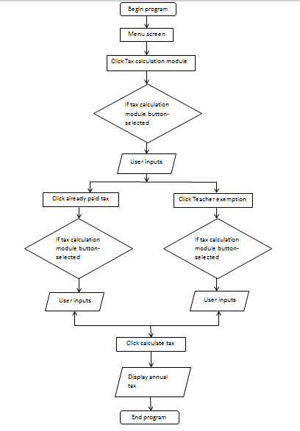

“Illustrating User Interactions and System Functionality”.

**SOURCE CODE**

import java.util.Scanner;

class IncomeTax

{

public static void main(String[] args)

{

Scanner scanner = new Scanner(System.in);

System.out.print("Enter Annual Income: ");

double annualIncome = scanner.nextDouble();

System.out.println("\n-----INVESTMENTS u/s 80C-----");

double lifeInsurancePremium = getInvestmentDetails("Life Insurance Premium Paid: ");

double providentFundContribution = getInvestmentDetails("Contribution to Provident Fund: ");

double publicProvidentFund = getInvestmentDetails("Public Provident Fund: ");

double nscSubscription = getInvestmentDetails("Subscription to NSC: ");

double ulip = getInvestmentDetails("Unit Linked Insurance Plan: ");

double principalPaymentHousing = getInvestmentDetails("Principal Payment of Housing: ");

double fiveYearFixedDeposit = getInvestmentDetails("Five Year Fixed Deposit: ");

System.out.println("\n-----INVESTMENTS u/s 80D-----");

double healthInsurancePremium = getInvestmentDetails("Health Insurance Premium: ");

double seniorCitizenHealthInsurance = getInvestmentDetails("Health Insurance Premium for Senior Citizen: ");

double preventiveHealthCheckup = getInvestmentDetails("Preventive Health Checkup: ");

System.out.println("\n-----INVESTMENTS u/s 80CCD-----");

double npsSelfContribution = getInvestmentDetails("Additional NPS Self Contribution (up to 50000): ");

double totalInvestments = lifeInsurancePremium + providentFundContribution +

publicProvidentFund + nscSubscription + ulip + principalPaymentHousing +

fiveYearFixedDeposit + healthInsurancePremium + seniorCitizenHealthInsurance +

preventiveHealthCheckup + npsSelfContribution;

double taxableIncome = annualIncome - totalInvestments;

double taxPayable = calculateTax(taxableIncome);

System.out.println("\n--- Income Tax Calculation Results ---");

System.out.println("Annual Income: " + annualIncome);

System.out.println("Total Investments: " + totalInvestments);

System.out.println("Taxable Income: " + taxableIncome);

System.out.println("Tax Payable: " + taxPayable);

}

private static double getInvestmentDetails(String message)

{

Scanner scanner = new Scanner(System.in);

System.out.print(message);

return scanner.nextDouble();

}

private static double calculateTax(double income)

{

double tax;

if (income <= 60000)

{

tax = 0;

}

else if (income > 60000 && income < 150000)

{

tax = income * 0.05;

}

else if (income > 150000 && income < 500000)

{

tax = income * 0.1;

}

else if (income > 500000 && income < 1000000)

{

tax = income * 0.2;

}

else if (income > 1000000 && income < 2000000)

{

tax = income * 0.25;

}

else

{

tax = income * 0.3;

}

return tax;

}

}

**SCREENSHOTS(OUTPUT)**

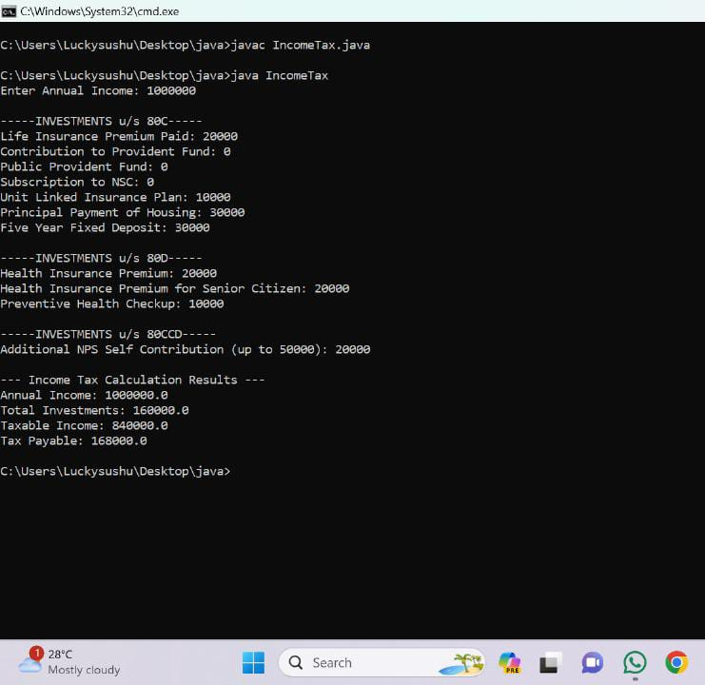

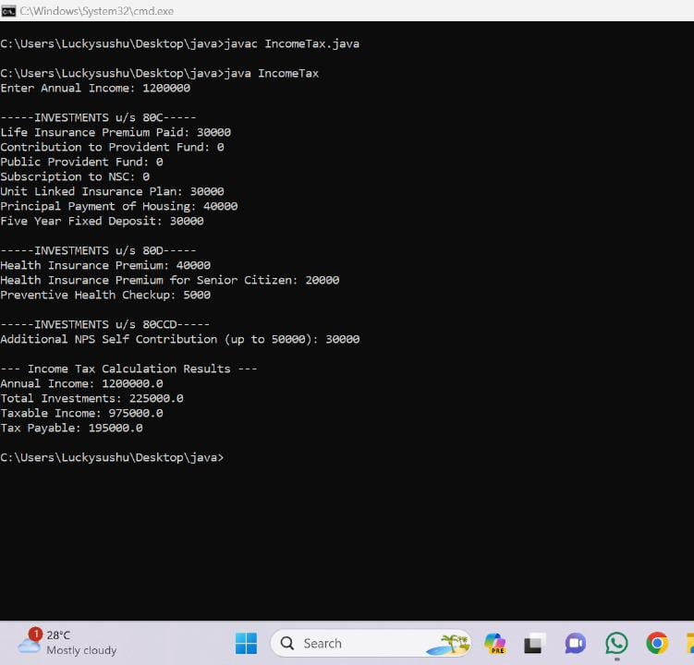

**CONCLUSION**

In conclusion, the development and implementation of the income tax calculator project have been successful in achieving its objectives. The project aimed to provide users with a user-friendly tool to calculate their income tax liability accurately and efficiently. Through thorough research, analysis, and programming, we have created a robust application that considers various tax brackets, deductions, and credits to provide users with precise results.

The user interface has been designed to be intuitive, allowing users to input their financial information easily. The algorithm behind the calculator takes into account the latest tax regulations and ensures compliance with tax laws. We have incorporated error-checking mechanisms to enhance the accuracy of calculations and provide users with reliable results.

In addition to the primary objective of accurate tax calculations, the project has potential for future enhancements. Integration with real-time tax rate updates, additional financial planning features, and improved user customization options could be explored in future iterations.

Overall, the income tax calculator project has been a rewarding endeavor, contributing to financial literacy and empowerment. It serves as a valuable tool for individuals and businesses to make informed decisions regarding their tax obligations. The successful completion of this project demonstrates our commitment to delivering practical and user-focused solutions in the realm of financial technology.

**REFERENCES**

<https://www.canarahsbclife.com/tools-and-calculators/income-tax-calculator>

<https://www.iciciprulife.com/insurance-guide/financial-planning-tools-calculators/income-tax-calculator.html>

<https://www.adityabirlacapital.com/abc-of-calculators/income-tax-calculator>

<https://cleartax.in/paytax/TaxCalculator>

<https://tax2win.in/guide/how-to-calculate-income-tax-on-salary#:~:text=The%20tax%20rates%20are%20determined,Tax%20Rate)%20%2D%20Tax%20Rebate>.